How to find papers
Spring 2016
Followings are some tips that may be applicable to find papers in your area of research. Let’s assume we attempt to research on a topic in “Drug Trafficking”. It is a good idea to start from looking for syllabuses on crime, econ, law:
The first item is a course from Harvard. If you open it you can find a paper on the topic you are interested, you find this paper on AER:
Dell, Melissa. "Trafficking networks and the Mexican drug war." The American Economic Review 105.6 (2015): 1738-1779.

Remember, you should look for a syllabus in top schools and they may be not related to your questions, at all. In any events, it is helpful to start from syllabus search in many cases. You also ought to know the ranking of journals. Here is the top ten journals in econ:
Journal Title | IF
American Economic Review * | 2.69
Econometrica * | 2.98
Quarterly Journal of Economics | 5.92
Journal of Political Economy * | 2.90
Journal of Finance * | 4.22
Review of Financial Studies * | 4.75
Journal of Monetary Economics | 1.89
Review of Economic Studies | 2.81
Review of Economics and Statistics | 2.66

Next, you can search within top journals, the key words related to your topic:
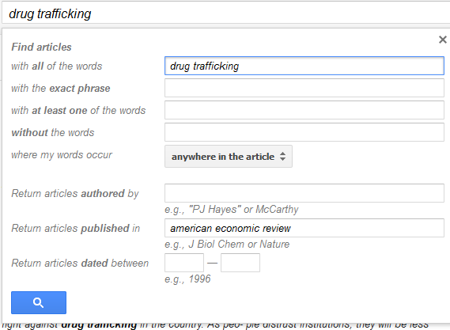
Which following papers show up in your search:
Elliott, Kimberly Ann, and Gary Clyde Hufbauer. "Same song, same refrain? Economic sanctions in the 1990's." The American Economic Review 89.2 (1999): 403-408.
Dobkin, Carlos, and Nancy Nicosia. "The war on drugs: methamphetamine, public health, and crime." The American economic review 99.1 (2009): 324.
Let’s keep up with the paper you found. You can see there is an icon called “Related articles”, it is worth trying, though not a useful try for “drug trafficking” topic.
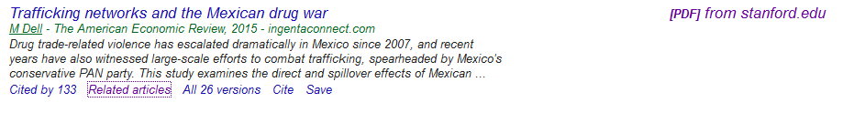
Second, if you go to its references you can find further papers may be related to your works.
Di Tella, R. and E. Schargrodsky (2004): Do police reduce crime? Estimates using the allocation of police forces after a terrorist attack," The American Economic Review, 94, 115{133.
Levitt, S. and S. Venkatesh (2000): An Economic Analysis of a Drug-Selling Gang's Finances, The Quarterly Journal of Economics, 115, 755

